**Task # 01:**

**Create a database to record employees’ information. Create a user friendly GUI to:**

1. **Insert employees information**
2. **Update employees information**
3. **Delete employees information &**
4. **Search employee**

**Employee Class:**

class Employee

{

public int ID { get; set; }

public string Name { get; set; }

public int Age { get; set; }

public int Salary { get; set; }

public string Address { get; set; }

public string Description { get; set; }

}

**DatabaseHelper Class:**

class DatabaseHelper

{

SqlConnection conn;

SqlCommand cmd;

SqlDataAdapter sda;

DataTable dt;

static Messages msg;

public DatabaseHelper()

{

msg = new Messages();

string connectionString = @"Data Source=SHAHGEE\Arbab;Initial Catalog=EmployeeData;Integrated Security=True";

conn = new SqlConnection(connectionString);

}

public bool DataManipulationOperation(string query)

{

try

{

conn.Open();

cmd = new SqlCommand(query, conn);

int count = cmd.ExecuteNonQuery();

if (count > 0)

{

conn.Close();

return true;

}

}

catch (Exception ex)

{

msg.UserDefinedErrorMessage(ex.Message);

}

conn.Close();

return false;

}

public DataTable DataNavigationOperations(string query)

{

try

{

cmd = new SqlCommand(query, conn);

sda = new SqlDataAdapter(cmd);

dt = new DataTable();

sda.Fill(dt);

if (dt.Rows != null)

{

return dt;

}

}

catch (Exception ex)

{

msg.UserDefinedErrorMessage(ex.Message);

}

return null;

}

}

**Form1(Search) Class:**

public partial class Form1 : Form

{

DatabaseHelper db;

Messages msg;

public Form1()

{

db = new DatabaseHelper();

msg = new Messages();

InitializeComponent();

}

private void Form1_Load(object sender, EventArgs e)

{

string query = "select * from Employee";

DataTable dt = db.DataNavigationOperations(query);

dataGridView1.DataSource = dt;

}

private void button4_Click(object sender, EventArgs e)

{

try

{

string query = "select * from Employee where name like '%" + NamesTxt.Text + "%'";

DataTable dt = db.DataNavigationOperations(query);

dataGridView1.DataSource = null;

dataGridView1.DataSource = dt;

}

catch (Exception ex)

{

msg.UserDefinedErrorMessage(ex.Message);

}

}

private void RefreshBtn_Click(object sender, EventArgs e)

{

string query = "select * from Employee";

DataTable dt = db.DataNavigationOperations(query);

dataGridView1.DataSource = dt;

}

}

**Messages Class:**

class Messages

{

public void SuccessMessage()

{

MessageBox.Show("Action successfully performed!", "Success", MessageBoxButtons.OK, MessageBoxIcon.Information);

}

public void ErrorMessage()

{

MessageBox.Show("An error occured!", "Error", MessageBoxButtons.OK, MessageBoxIcon.Error);

}

public void UserDefinedSuccessMessage(string msg)

{

MessageBox.Show(msg, "Success", MessageBoxButtons.OK, MessageBoxIcon.Information);

}

public void UserDefinedErrorMessage(string msg)

{

MessageBox.Show(msg, "Error", MessageBoxButtons.OK, MessageBoxIcon.Error);

}

public DialogResult QuestionMessage(string msg)

{

return MessageBox.Show(msg, "Question", MessageBoxButtons.YesNo, MessageBoxIcon.Question);

}

}

**AddEmployee Class:**

public partial class AddEmployee : Form

{

Messages msg;

DatabaseHelper db;

public AddEmployee()

{

msg = new Messages();

db = new DatabaseHelper();

InitializeComponent();

}

private void SaveBtn_Click(object sender, EventArgs e)

{

try

{

if (msg.QuestionMessage("Do you really want to add?") == DialogResult.Yes)

{

Employee obj = new Employee();

obj.ID = int.Parse(IDTxt.Text);

obj.Name = NameTxt.Text;

obj.Age = int.Parse(AgeTxt.Text);

obj.Salary = int.Parse(SalaryTxt.Text);

obj.Address = AddressTxt.Text;

obj.Description = DescriptionTxt.Text;

string query = "insert into Employee values(" + obj.ID + ",'" + obj.Name + "'," + obj.Age + ",'" + obj.Address + "'," + obj.Salary + ",'" + obj.Description + "')";

if (db.DataManipulationOperation(query))

{

msg.UserDefinedSuccessMessage("Employee added successfully");

RefreshData();

}

}

}

catch (Exception ex)

{

msg.UserDefinedErrorMessage(ex.Message);

}

}

private void RefreshBtn_Click(object sender, EventArgs e)

{

RefreshData();

}

private void RefreshData()

{

IDTxt.Text = AgeTxt.Text = SalaryTxt.Text = AddressTxt.Text = DescriptionTxt.Text = string.Empty;

NameTxt.Text = string.Empty;

}

}

**Update Delete Employee Class:**

public partial class UpdateDeleteEmployee : Form

{

DatabaseHelper db;

Messages msg;

public UpdateDeleteEmployee()

{

db = new DatabaseHelper();

msg = new Messages();

InitializeComponent();

}

private void SaveBtn_Click(object sender, EventArgs e)

{

if (msg.QuestionMessage("Are you sure you want to update this information?") == DialogResult.Yes)

{

if (IDTxt.Text != null)

{

string query = "update Employee set Name='" + NamesTxt.Text + "',Age=" + AgeTxt.Text + ",Address='" + AddressTxt.Text + "',Salary=" + SalaryTxt.Text + ",Description='" + DescriptionTxt.Text + "' where id="+IDTxt.Text+"";

if (db.DataManipulationOperation(query))

{

msg.UserDefinedSuccessMessage("Data successfully updated");

}

else

{

msg.UserDefinedErrorMessage("An unexpected error occured while updating employee");

}

}

}

}

private void DeleteBtn_Click(object sender, EventArgs e)

{

if (msg.QuestionMessage("Are you sure you want to delete this employee?") == DialogResult.Yes)

{

if (IDTxt.Text != null)

{

string query = "delete from Employee where id=" + IDTxt.Text + "";

if (db.DataManipulationOperation(query))

{

msg.UserDefinedSuccessMessage("Employee Deleted Successfully");

}

else

{

msg.UserDefinedErrorMessage("An unexpected error occured while deleting employee");

}

}

else

{

msg.UserDefinedErrorMessage("Kindly select any employee to delete");

}

}

}

private void UpdateDeleteEmployee_Load(object sender, EventArgs e)

{

string query = "select * from Employee";

DataTable dt= db.DataNavigationOperations(query);

foreach(DataRow dr in dt.Rows)

{

NamesTxt.Items.Add(dr[1].ToString());

}

}

private void NamesTxt_SelectedValueChanged(object sender, EventArgs e)

{

if (NamesTxt.Text != null)

{

string query = "select * from Employee";

DataTable dt = db.DataNavigationOperations(query);

foreach (DataRow dr in dt.Rows)

{

if (dr[1].ToString() == NamesTxt.Text)

{

IDTxt.Text = dr[0].ToString();

AgeTxt.Text = dr[2].ToString();

AddressTxt.Text = dr[3].ToString();

SalaryTxt.Text = dr[4].ToString();

DescriptionTxt.Text = dr[5].ToString();

}

}

}

}

private void RefreshData()

{

IDTxt.Text = AgeTxt.Text = SalaryTxt.Text = AddressTxt.Text = DescriptionTxt.Text = string.Empty;

NamesTxt.Text = string.Empty;

}

**Output**:

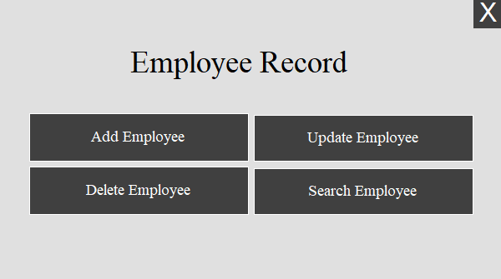

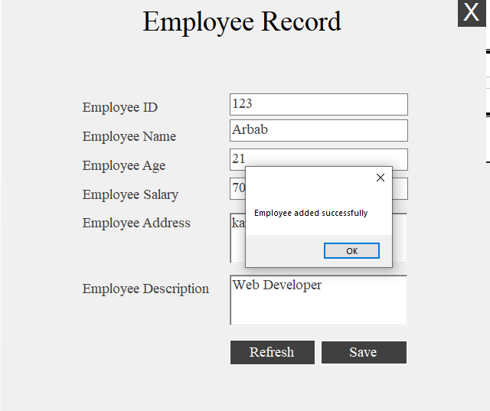

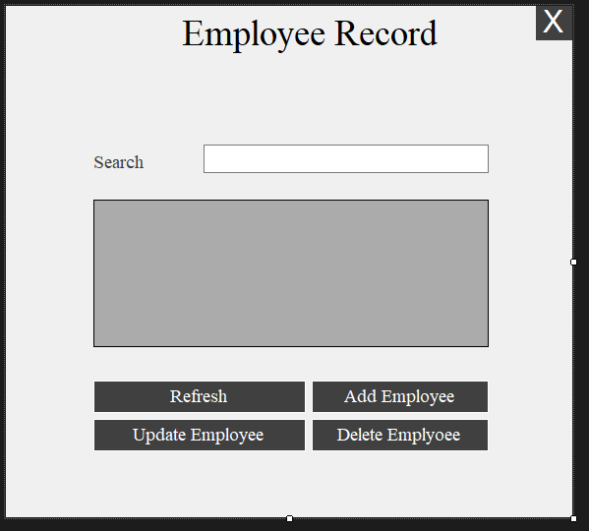

**Task # 02:**

**Create a form which contain the information of the students enrolled for accessing the university site. The information that should be taken from form should include StudentID,FirstName, LastName,Gender, DOB , Address, Department, Program. The operations that could be perform through windows form application should include Save, Update, Delete and search along with these function a button should be included with the name Read which can on click provide the data saved in database in the DataGridview.**

**Note: We can use same above code for saving record of Student Just by changing their objects names.**

**Output:**

